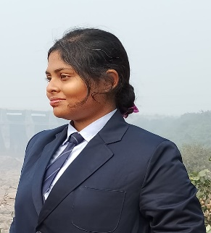**RESUME**

**POULAMI MITRA**

+91 7501973433

Email id: [poulami320@gmail.com](mailto:poulami320@gmail.com)

Linkedin: https://www.linkedin.com/in/poulami-mitra-857555237

**OBJECTIVE**

To work with an organization where I can learn new skills and increase abilities for the organizational goals as well as myself.

**EDUCATIONAL QUALIFICATION**

* Pursuing B.Tech 4th year from Asansol Engineering College
* Passed out class 12 from CBSE in 2020
* Passed out class 10 from CBSE in 2018

**PROJECTS**

* Anti Sleep Alarm for Drivers
* Movie Ticket Booking Website

**TECHNICAL SKILLS**

* Basic Knowledge of computer
* Languages known
  + C
  + JAVA
  + HTML
  + PYTHON
  + DBMS ( Using Oracle)

**WORK EXPERIENCE**

FRESHER

**STRENGTH AND HOBBIES**

* Hard & Smart Work
* Honest & Punctual
* Good Communication skills
* Arts, Drawing and Dance

**PERSONAL DETAILS**

Father’s Name : Mr. Pulak Chandra Mitra

Date of Birth : 14th December 2002

Address : Aurobinda Nagar, Road-8,Hindustan Cables,P.Barshaman,Pin-713335

Marital Status : Single

Date: *21st June 2023* (Poulami Mitra)